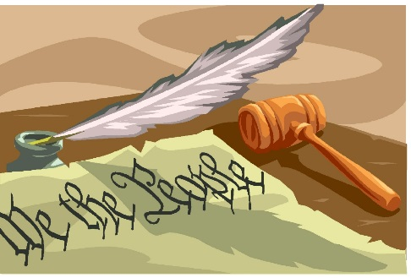
Shepard Academy Senior Block

Mrs. Hahn and Mr. Barringer

Poetry Explication

What Is Explication & How Do I It?
Analytical writing with the purpose to explain or interpret is also called explication: unfolding or making clear the meaning of a text. When we write an explication of a poem, we are explaining its meaning. This necessarily involves interpretation. An explication of a poem will explain to us the possible meanings of an element or a particular passage of a poem while pointing out the ways and means the author uses to imbue the poem with meaning. To do this, you will craft your own prompt and respond to it in more extended fashion than in a normal AP timed writing: 3-5 pages.

Here’s a step-by-step guide to creating your poetry explication.

- Choose two paired poems to explore.
1. “A Barred Owl” and “The History” Teacher – Write an essay in which you analyze how adults provide
explanations for children.
2. “Five A.M.” and “Five Flights Up” – Write an essay in which you analyze the speakers’ reflections on their
early-morning surroundings
3. “When I Have Fears” and “Mezzo Cammin’” – Write an essay in which you analyze the similar concerns these
two poets explore.
4. “To Sir John…” and “When I Was…” – Write an essay in which you analyze the idea of coming of age at 21.

- TPCASTT your poems.
Before you begin writing your explication, jot down a short paragraph for each letter of TPCASTT. See the TPCASTT documents on my website or look at your Reader Response Journals for examples.

3) Write an introduction that familiarizes us with your poems and the theme they address. End it with a clear thesis that answers the prompt.

4) Write your body paragraphs.
Each paragraph must include a topic sentence and plenty of examples (use a mixture of quotes and paraphrases)
that are clearly explained. Make sure you clarify why these examples prove your point. Remember, this is an
argument.

5) Write your conclusion.
Your conclusion should flow smoothly from the rest of your essay and prove your points without simply restating.

