English 105: Creative and Aesthetic Expression
Syllabus – Semester and Year

Instructor Information
Peter Barringer
Room 101 / peter.barringer@evsck12.com
Office Hours: Daily, 2:30 to 3:00 p.m. by request

Course Information
3 Credit Hours
Meeting Time(s) and Location(s): Daily (in person) in room 101, 11:33 to 12:07

Welcome Statement - About This Course
- Some students ask me why we study literature as part of the Shepard Academy curriculum, and it’s a valid question. If we’re being honest, few professions will require you to analyze literature. But most careers do require the exact skills you’ll be developing in this class: close reading, analytical writing, critical thinking, and deep, collaborative discussion. I guarantee English 105 will help you in your future career. Maybe it will foster a love of literature in you, too!
- On a personal note, my dad enjoyed a long and successful career as a corporate attorney. He says new attorneys frequently need help with writing skills because they are deficient in grammar and analytical writing strategies. In fact, law schools cite English as a suitable major for pre-law programs. I hope I’ve convinced those of you who are interested in law, government, or political careers.
- However, even if you’re not interested in law, this class will help you develop the crucial skills necessary for any high-level profession.

Course Description
An introduction to literature emphasizing the ability to read critically. Topics vary.

Course Learning Outcomes
By the end of this course, you will be able to:
- Read culturally-relevant works of literature closely.
- Analyze high-level texts of any genre.
- Critically think about difficult topics and texts that apply to the real world.
- Discuss literature and current event connections deeply.
- Write analytically about significant aspects of literature.

Program Learning Outcomes
Communications Skills: Develop close- and critical-reading skills through discussion as well as formal and informal writing about a variety of texts.
Critical Thinking: Develop skills in critical reading and analysis through the application of theoretical approaches to a variety of texts.
Cultural and Historical Awareness/Diversity: Understand the major socio-historical contexts informing the study of American/British literature.
Disciplinary Skills and Practice: Understand the distinctions between major literary genres; understand, at the introductory level, significant theoretical orientations that inform ways of reading texts; develop an understanding of the range of disciplines included in English studies; understand the terminology of American/British literature through major periods and literary movements.
Applications of Knowledge and Skills: Develop as emerging professionals with skills and habits of mind that will help them achieve success in further study in the discipline and the diverse professions they will pursue; become multi-dimensional readers, thinkers, and writers; develop civic-mindedness and a desire to influence and transform their communities and the world.

Textbook and/or Course Materials:
- The Stranger by Albert Camus
- Fences by August Wilson
- Short stories and poems chosen and distributed by the instructor

Course Policies and Expectations
- The success of this course depends on your willing participation, your diligence in reading your assignments, and respect for the other people taking the course. Please come to class daily and participate. Students who miss multiple classes will face automatic consequences from the assistant principal’s office. Per EVSC policy, missing 10 or more classes can result in loss of high school credit.
- If you are absent on the day of a test or in-class writing, you may have an alternative make-up assessment. Unexcused absences result in the inability to make up an exam.

Grading, Assignments, Exam, and Related Policies
- Your grade is comprised of 40% from your first nine weeks grade, 40% from your second nine weeks grade, and 20% from your final exam.
- This class utilizes weighted grading categories:
  - Formative Assessments such as homework and in-class work (30%): ~20 formative assessments (primarily small-group discussion and individual journal prompts)
  - Summative Assessments such as tests and essays (70%): poetry journals, poetry essay, reading quizzes (~3 per book), and tests all over long works.
- Your high school grade is calculated the same way as the college grade. However, USI classes allow for “plusses” at the end of your grade. For clarity, here’s a table that shows the cutoffs:
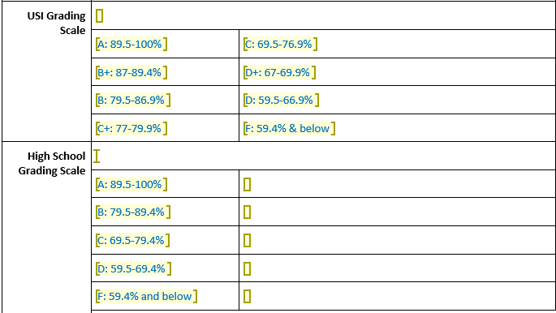
- I expect assignments to be submitted by the date and time indicated on the Weebly (barringerlit.weebly.com) and Google Classroom. Please only utilize our school’s late work policy (all late work is accepted) for extenuating circumstances. Note that this policy only applies to homework; in-class work must be completed by the due date and time.
- I expect you to initiate your own make-up work. Any time you miss part or all of a class for any reason, you should check the Weebly site and check with classmates. See me with questions. Work missed due to truancy may not be made up.
- While high schools may be permitted to incorporate retesting and flexible attendance for the purpose of content mastery, CAP courses must follow the same grading and assessment practices that are utilized by the USI department. Thus, a student may have flexibility with retesting options for the high school grade, but a single opportunity to take a test, quiz, or even complete an assignment for USI. If USI permits retest options, those will be outlined below. It is worth noting that colleges do not typically permit retesting.
- All work submitted for this course must be your own and written exclusively for this course. If you have any questions regarding this policy, please see me. According to the University of Southern Indiana Bulletin, “The University considers plagiarism a form of academic dishonesty and proof of plagiarism may subject a student or student organization to disciplinary action as outlined in the University of Southern Indiana Code of Conduct.” Penalties for plagiarism range from failure on an individual assignment to dismissal from the university, depending on the severity of the infraction.

AI Tools Use in This Course
- Artificial intelligence (AI) tools that generate text, images, code, and other content are widely available. If you submit work containing any content generated by AI when not explicitly allowed and not in a way directed by me, the instructor, then this will be considered academic dishonesty and a violation of USI’s academic integrity policy. If you are not sure about what may be academic dishonesty or plagiarism and what is acceptable use in this course and on specific assignments, please contact me to discuss.
- Generative AI use is prohibited. You are not permitted to use AI tools that generate content (such as ChatGPT, Bing Chat, Bard, DALL-E) for work done for this class. Writing, analytical, and critical thinking skills are part of your learning outcomes in this course; therefore, all writing assignments should be prepared by you, the student. Content created by generative AI tools may not be considered your own original work. This course assumes that work submitted by students (all process work, drafts, final versions, and all other submissions) will be generated by the students themselves, working individually or in groups (as directed).

Additional Course and University Policies (Syllabus Statements)
Please become familiar with the policies and guidance on the following topics by viewing the Course and University Policies (Syllabus Statements). This link also is available on the Blackboard course menu.
- Academic Continuity
- Academic Integrity
- AI Tools Use
- Civility and Inclusion
- Disability Accommodations
- Safety: Emergency Evacuation and Shelter-in-place Instructions
- Student Basic Needs
- Title IX - Sexual Misconduct

Syllabus Change Policy
This syllabus is a guide to the course and is subject to change with reasonable advanced notice as course needs arise.

Course Outline and Schedule
This schedule shows which weeks of the semester will be dedicated to each unit. It also indicates which assignments we will complete during each unit. However, daily agendas and lessons are adjusted frequently. As such, please refer to my website (barringerlit.weebly.com) and scroll over SHEPARD ACADEMY CAP to find specific, daily lesson plans.

Weeks One through Five (Early January through Early February): Poetry Bootcamp
- Lessons over the elements of poetry
- Reader Response Journals
- Literary Analysis essay: Write an interpretation of a piece of literature that is based on a careful observation of textual details, considering the work's structure, style, and themes; social and historical values; use of figurative language, imagery, symbolism, and tone

Weeks Six through Nine (Early February through Mid-March): The Stranger
- Poetry connections, short story connections, ancillary readings, video comparisons, historical background, modern music comparisons, class discussions, close readings
- Study guide (literary data sheet)
- Text- and government-related discussions as part of the Shepard Academy
- Timed writing assessment

Weeks Ten through Fourteen (Mid-March through End of April): Fences
- Poetry connections, short story connections, ancillary readings, video comparisons, historical background, modern music comparisons, class discussions, close readings
- Introduction to literary theory
- Daily reading quizzes
- Timed Writing assessment

Weeks Fifteen through Nineteen: Short Fiction, Final Exam, and Reflections
- Class discussion, small group discussion, close readings, and reading quizzes
- Analysis focused on comparing/contrasting two works thematically (builds to the final exam)
- Literary Technique review
- Final Exam preparation and Final Exam

