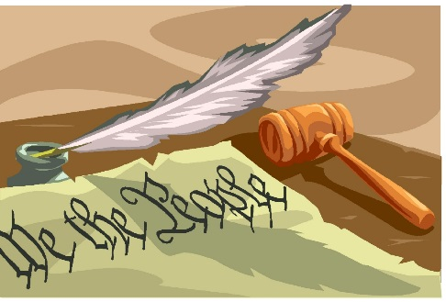
Shepard Academy Senior Block

Mrs. Hahn and Mr. Barringer

PART TWO
Chapter One
1. What are the potential implications or consequences of the girl’s note—for her and for Winston?
2. Explain the contrasting images in the final line of this chapter.
3. Make a prediction. Is the girl what she seems? Explain why or why not. Consider the note, the specificity of her directions, the precise, military-like method of giving instructions, etc.

Chapter Two
1. Explain why Winston says this line: “The more men you’ve had, the more I love you. Do you understand that?”
2. Besides being a blow struck against the Party, how else is Julia (and Winston’s relationship with her) symbolic?

Chapter Three
1. What does Julia’s “experience” allow you to infer about the nature of her budding relationship with Winston?
2. Respond to the following line: She could describe the whole process of composing a novel, from the general directive issued by the Planning Committee down to the final touching-up by the Rewrite Squad.
3. On page 166, why does Julia already knows the details of Winston’s marriage?
4. Summarize why it’s so important for the government to make sure sex is controlled.
5. Explain the irony of the line, “we are the dead” on page 170.
6. Identify the example of foreshadowing earlier in this chapter that pertains to their next meeting in the woods.

