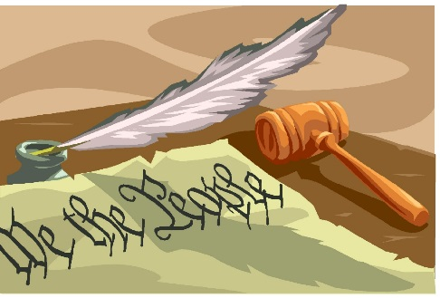
Shepard Academy Senior Block

Mrs. Hahn and Mr. Barringer

Chapter Six
1. Given the new information about Winston’s wife, what can we now infer about why Winston hates the dark-haired girl from the Junior Anti-Sex League so severely?
2. Do you think Orwell went too far in suggesting that the government could manipulate and even eliminate people’s sexuality, or is the idea plausible?

Chapter Seven
1. Explain the first sentence and its significance.
2. Explain why the proles do not need to be controlled despite making up 85% of the population.
3. “Mrs Parsons, a woman with lined face and wispy hair, fiddling helplessly with a blocked waste-pipe.” What’s the symbol or metaphor here, and how does it apply to the populace as a whole?
4. What events have actually happened in the narrative so far? Fill out the exposition and rising action sections of a plot arc. Predict what the climax, falling action, and resolution might be.
5. On page 96 we see that the traitors disappeared for a year before confessing to their crimes. What happened during that year that caused them to confess?
6. Why does it matter that Winston found concrete proof of the government’s falsification of records?
7. What lines near the end of this chapter prove that Winston is really beginning to break loose from the shackles of mind control and have more profound thoughts?

Chapter Eight
1. Why did Orwell include the graphic depiction of the hand?
2. Why does the government have a lottery for the proles?
3. Big Brother vilifies capitalism. Are any of the arguments against capitalism (see pages 113-114) good?
4. The old man is one of few remaining proles who was alive before the wars. Explain why he, in particular, is still alive.
5. Compare and contrast the dialect of the old man and the dialect of the shopkeeper.

