Prose/Poetry Essay Process (Barringer)
STEP ONE (Break down the prompt): Read the prompt twice carefully. Underline what it’s asking you to write about (Common examples: an attitude, a relationship, someone’s response to an event).
STEP TWO (Read the passage): Read the passage carefully, looking for whatever the prompt is asking about as you read.
STEP THREE (Divide the text into sections): Go back after reading and draw 1-3 lines at places when there’s an obvious shift in the topic you’re writing about (Example: if you’re asked about someone’s complex attitude, where are spots where their attitude changes? Draw lines there.)
STEP FOUR (Literary techniques): Are there any literary techniques that ACTUALLY help you see whatever topic you’re being asked to cover? (Example: you can easily see someone’s attitude through their word choice [diction], thoughts [interior monologue], and dialogue.)
STEP FIVE (Intro): Start writing your essay. The intro can be short. Introduce the piece and author, then provide a quick summary. End with a thesis that ACTUALLY answers the question. This is crucial for earning your thesis point. It’s also a good idea to preview the theme you’ll discuss in the conclusion, but this isn’t completely necessary. Don’t give away the whole theme statement, though. (Example thesis with theme preview: The poem’s speaker moves from uncertainty about her new relationship to joy at the fulfillment it provides; her eventual disappointment with her partner ultimately shows what happens when novelty wears off in a relationship.)
STEP SIX (Body paragraphs): Each body paragraph will cover one of the 2-4 sections of the text you created in step 3. For each body paragraph, start with a clear topic sentence that explains the first part of your thesis. (Example: In lines 1-16, the speaker is experiencing uncertainty about her new relationship.) From there, begin alternating text evidence (whether paraphrase or quote) and your own commentary about that evidence. Think of your commentary as answering the question, “So what?” You gave a piece of evidence, and now you need to explain why it’s significant, how it proves your point, or what it means. This is where literary techniques come in. If there’s a literary technique that ACTUALLY helps you see what you’re talking about, then use it as an example. Literary techniques are not your focus, they’re evidence only. You only need to use 1 or 2 to get full points for the essay, but you need to be able to actually explain how the technique, in our example, shows the speaker’s attitude. (How do you usually see someone’s attitude? Through their spoken words [dialogue], thoughts [called “interior monologue”], and diction [word choice].)
STEP SEVEN: (Conclusion): Start by re-stating your thesis (preferably in a different way) to ensure you earn your thesis point. Next, if you didn’t do so in the previous sentence, move into a brief explanation of the theme this piece conveys (Example: In this poem, the poet conveys how a sense of “the new” tends to wear off quickly, and our happiness often wears off with it.) From here, explain what this means in the real world and then connect back to the poem. (Example: Whether it’s a new possession, a relationship, or anything else, we often expect new things to fulfill us. And they only do so for a brief time. The speaker of this poem, like us, will be left to start the cycle over again as she searches for a new relationship that is bound to only fulfill her temporarily.)
Poetry Essay Partial Example (Freitas)
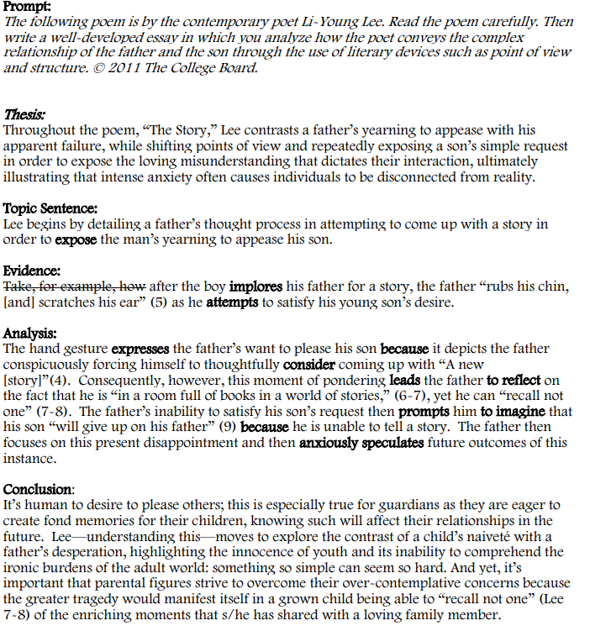

Open Response Essay Process (Barringer)
STEP ONE (Break down the prompt): Read the prompt twice carefully. Underline what it’s asking you to write about (betrayal, jealousy, sacrifice, love, growing up, home, friendship, etc.). There’s always a second part where it asks how this topic helps “illuminate the meaning of the work as a whole.” This is literally just asking you to explain how the examples you pick help you see the theme in the play or novel. That’s why many people call this the “theme essay.”
STEP TWO (Pick a text): Select a text we’ve read this year that matches up really well with the prompt.
STEP THREE (Pick a theme): From the themes you’ve tracked, select one that connects with the topic.
STEP FOUR (Pick examples): This part looks a bit different for each prompt. Generally, you’ll pick three examples of the topic from the text. I like to TRY to choose one from the beginning, middle, and end so I can show how the theme develops.
STEP FIVE (Intro): Start writing your essay. Introduce the piece and author, then provide a quick summary. End with a thesis that ACTUALLY answers the question. This is crucial for earning your thesis point. Mention the theme you’ll discuss in the conclusion but don’t give away the whole theme statement. (Example thesis about “sibling relationships” connecting with “guilt” as a theme topic: In Khaled Hosseini’s Kite Runner, Amir and Hassan share a complicated bond--both as friends, and as later discovered, brothers--belonging to two entirely different social spheres. Throughout Amir’s coming-of-age story, their relationship drives and deepens his central battle with guilt.)
STEP SIX (Body paragraphs): Each body paragraph will cover one of the examples you selected in Step 4. For each body paragraph, start with a clear topic sentence. (Example: Amir’s poor treatment of Hassan during their childhood at first creates little to no guilt inside him.) From there, begin alternating text evidence (whether paraphrase or quote) and your own commentary about that evidence. Think of your commentary as answering the question, “So what?” You gave a piece of evidence, and now you need to explain why it’s significant, how it proves your point, or what it means. It’s very, very crucial to give quick, SPECIFIC examples from the story to support your claim. Do not simply summarize the text, but think of it as using specific examples from the text to prove the point you made in your topic sentence. At the end of your body paragraphs, try to show how this example develops the theme and moves it along (Example: The pressure on Amir to choose between his own image and his relationship with Hassan causes his struggle with guilt to fester as the novel progresses.)
STEP SEVEN: (Conclusion): Start by re-stating your thesis and main examples (preferably in a different way) to ensure you earn your thesis point. Next, if you didn’t do so in the previous sentence, move into a brief explanation of the theme this piece conveys (Example conclusion: For over three decades of his life, Amir bears the guilt caused by his two conflicting lives and betraying Hassan. It eats him from the inside out, and it forces him to come face to face with his mistakes. As Kite Runner follows Amir’s battle with guilt, it also documents his climb toward redemption and forgiveness, not only from those he harmed, but from himself, finding it as he finally sacrifices himself for Hassan’s son. Through his exploration of Amir and Hassan’s complicated sibling relationship and Amir’s quest for redemption, Khaled Hosseini ultimately suggests that guilt, however unbearable, eventually leads to good, and that forgiveness is a blessing one must work to receive.)
Open Response Essay Partial Example (Freitas)
