Reconstruction of ruined Darul Aman palace begins in Kabul

30 May 2016

An ambitious project to reconstruct the historic Darul Aman palace, which was reduced to ruins in the Afghan civil war, has begun in the capital, Kabul.
The majestic structure was built in the 1920s on a hilltop overlooking the city by King Amanullah, who defeated the British to gain full Afghan independence.
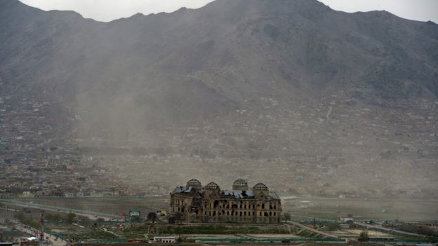
It was gutted by fire, then restored and served as the defense ministry in the 1970s and 1980s. When civil war broke out, it was used as a base by militias and suffered heavy shelling.
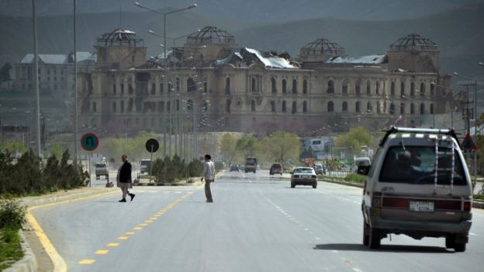
The damaged building was a reminder of the country's "darkest days", Afghan President Ashraf Ghani said as he inaugurated the reconstruction project. "Today, we witness returning to the past while building a foundation for the future," he added.
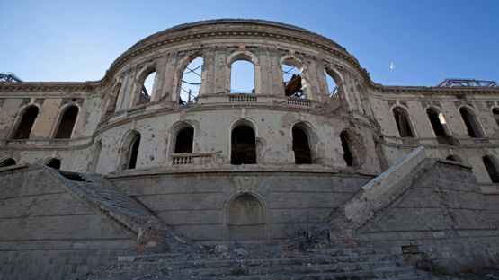
Fundraising for the palace reconstruction began with a government campaign in 2012. The project is expected to cost between $16.5m and $20m (£11.3m-£13.7m) and take three to five years, officials say.
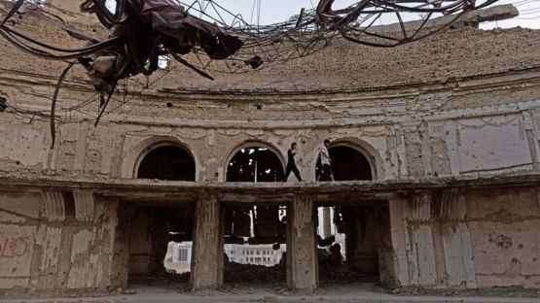
"Its reconstruction, funded by the Afghan government, is in itself of symbolic significance," says Waheed Massoud, editor of the BBC Afghan Service. "It shows the government's dedication to culture and history, and to the reconstruction of the country in general, as most of the significant development work is foreign funded."
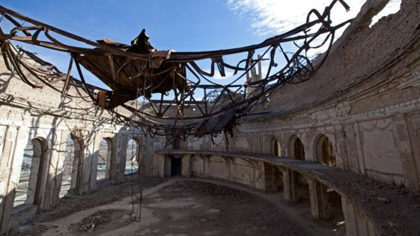
The renovated palace will be used as a museum and a venue for national ceremonies.

