W.B. Yeats – “The Second Coming”

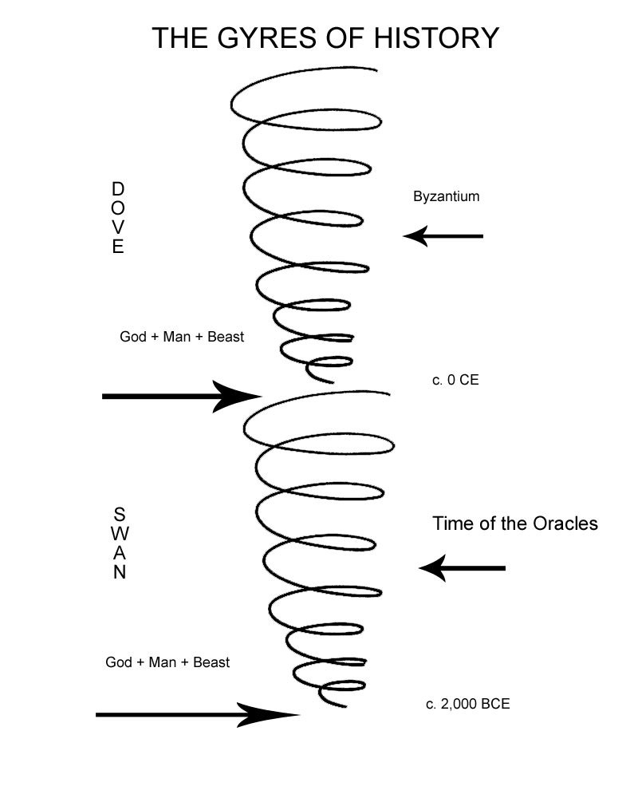
One version of Yeats' philosophy concerning gyres.

1. How would you describe the tone of “The Second Coming”? Look in the first stanza at the vision of the world the poet expresses. Look at how he describes the state of things.

2. What do you think Yeats means by the first two lines: “Turning and turning in the widening gyre / The falcon cannot hear the falconer.” Look up the word “gyre,” particularly Yeats’ use of the word. Consider what Yeats suggests about the world situation with the image of the falcon that cannot hear the falconer.

3. What is the tone of the first few lines of the second stanza? How would you describe the emotion of this voice? What is the “second coming?” What is it about the second coming that the poet seems to beseech? How does the second coming become darkly ironic by the end of the poem?

4. Starting on the fourth line of the second stanza, describe the poet’s vision. What is the “vast image” he sees? How do you interpret what he sees, and what it represents?

5. The poem was written in 1922, not too long after the end of World War I. Even though many thought it was the war to end all wars, what does Yeats seem to prophecy in this poem? What type of future does he seem to envision?

